Bunbury Senior High School Name:__SOLUTIONS______________

Total time allowed: 55 minutes

Test 6 Total Marks _____ / 50 _____%
Mathematics: Methods Unit 2
Test 6, 2018
Differentiation and Integration with Applications

Section One:
Calculator-free
Time allowed for this section: 20 minutes

Total marks for this section: 18 marks
Materials required for this section:
SCSA Formula Sheet

Instructions to candidates
Show all your working clearly. Your working should be in sufficient detail to allow your answers to be checked readily and for marks to be awarded for reasoning. Incorrect answers given without supporting reasoning cannot be allocated any marks. For any question or part question worth more than two marks, valid working or justification is required to receive full marks. If you repeat any question, ensure that you cancel the answer you do not wish to have marked.

Question 1 | [1, 2 = 3 marks]

a) Differentiate the following functions. Express all derivatives with positive powers.

i) $y=-4x^{3}$

$\frac{dy}{dx}=-12x^{2}$ correct

ii) $y=\frac{2x^{2}}{5}-\frac{1}{x^{3}}$

$y=\frac{2}{5}x^{2}-x^{-3}$

$\frac{dy}{dx}=\frac{4}{5}x+3x^{-4}$ correctly applies $\frac{dy}{dx}=anx^{n-1}$ to the negative power term

$\frac{dy}{dx}=\frac{4}{5}x+\frac{3}{x^{4}}$ correct with positive powers

Question 2 | [3, 3 = 6 marks]

a) Determine the equation of the tangent to the curve $y=x^{3}-4x^{2}-3$ at the point (2, -11).

$\frac{dy}{dx}=3x^{2}-8x$ correct derivative

${\left.\frac{dy}{dx}\right|}_{x=2}=3{(2)}^{2}-8\left(2\right)=-4$ evaluates derivative at $x=2$

$∴y=-4x+c$

solving $-11=-4(2)+c$

$c=-3$

$∴y=-4x-3$ correctly determines equation of the tangent

b) Determine the x-coordinates of any stationary point(s) of the function $f\left(x\right)=-2x^{3}+6x^{2}+18x$

$f^{'}(x)=-6x^{2}+12x+18$ correct derivative

solving $0=-6x^{2}+12x+18$ indicates stationary points occur at points of zero gradient

$0=x^{2}-2x-3$

$0=(x+1)(x-3)$

x-coordinates of the two stationary points are,

$x=-1$ and $x=3$ correct x-coordinates

Question 3 | [2 marks]

Determine the following integral.

$\int{-12x^{5}+3x^{2} dx}$

$=\frac{-12x^{6}}{6}+\frac{{3x}^{3}}{3}+c$ correctly applies anti-derivative to polynomial expression

$=-2x^{6}+x^{3}+c$ correctly simplifies with constant of integration included

Question 4 | [2 marks]

Given the sketch of $y=f(x)$, sketch a possible graph of $y=f'(x)$ on the axis below.

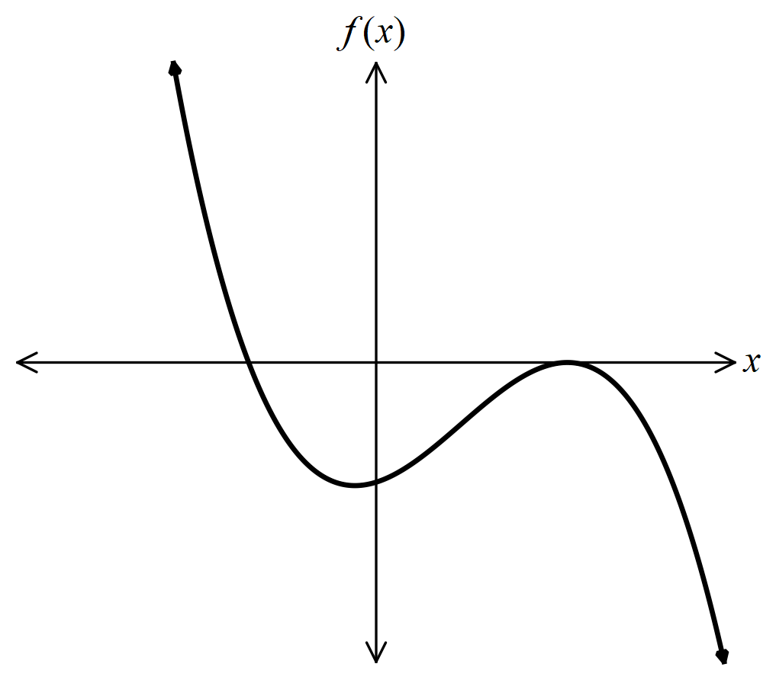

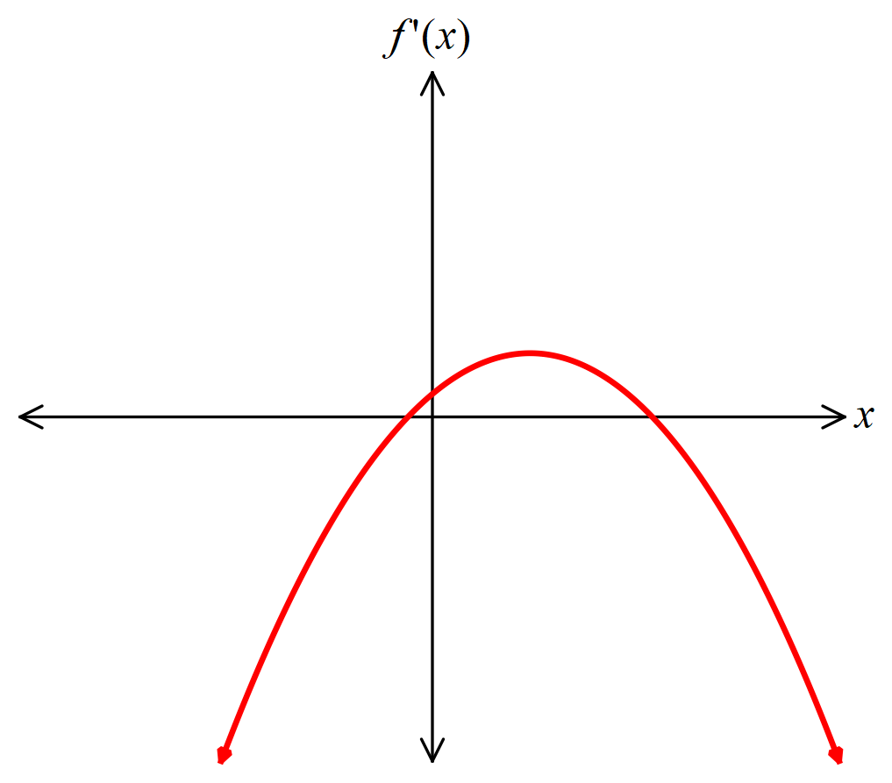

shows roots of $f'(x)$ occur when $f(x)$ has a turning point.

correct parabola shape.

Question 5 | [1, 2, 1, 1 = 5 marks]

The accompanying diagram shows the displacement (metres) time graph of an object P moving in a straight line from a fixed point O for $0≤t≤10$ seconds.
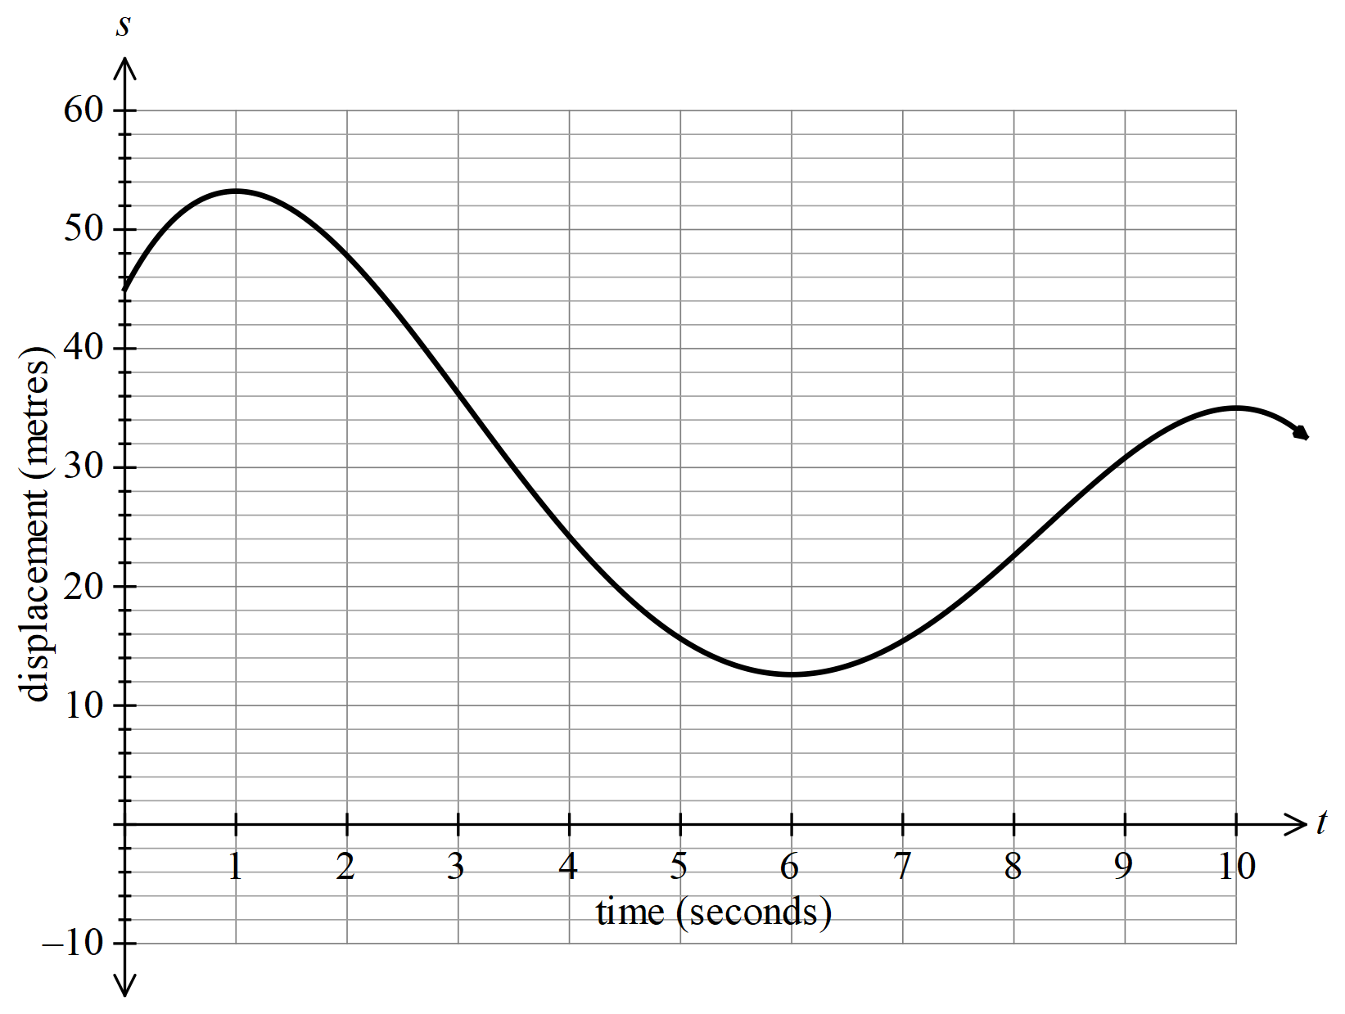

Use this diagram to estimate:

a) the initial displacement of P

$s\left(0\right)≈45$ m estimate of 45 m ± 1 m

b) when the object P is at rest

$v\left(1\right)=v\left(6\right)=v(10)≈0$ m/s

when $t≈1, 6 and 10$ seconds at least two of t = 1, 6 and 10 seconds ± 0.1 seconds
all three times

c) the velocity of P at $t=7$ seconds

$v\left(7\right)≈5$ m/s estimate of 5 m/s ± 1 m/s

d) when the velocity of P is -12 m/s.

$v\left(3\right)≈-12$ m/s

when $t≈3$ seconds estimate of t = 3 seconds ± 0.5 seconds

Bunbury Senior High School Name:__SOLUTIONS______________

Mathematics: Methods Unit 2
Test 6, 2018
Differentiation and Integration with Applications

Section Two:
Calculator-assumed
Time allowed for this section: 35 minutes

Total marks for this section: 32 marks
Materials required/recommended for this section:
SCSA Formula Sheet
Notes on one sheet (both sides) of A4 paper
Up to three approved calculators

Instructions to candidates
Show all your working clearly. Your working should be in sufficient detail to allow your answers to be checked readily and for marks to be awarded for reasoning. Incorrect answers given without supporting reasoning cannot be allocated any marks. For any question or part question worth more than two marks, valid working or justification is required to receive full marks. If you repeat any question, ensure that you cancel the answer you do not wish to have marked.

Question 6 | [4 marks]

Find the derivative of $y=3x^{2}$ from first principles.

$\frac{dy}{dx}=\lim_{h→0}{\frac{3{\left(x+h\right)}^{2}-(3x^{2})}{h}}$ correctly applies function into first principles limit

$\frac{dy}{dx}=\lim_{h→0}{\frac{3\left(x^{2}+2xh+h^{2}\right)-3x^{2}}{h}}$ expands ${(x+h)}^{2}$

$\frac{dy}{dx}=\lim_{h→0}{\frac{3x^{2}+6xh+3h^{2}-3x^{2}}{h}}$

$\frac{dy}{dx}=\lim_{h→0}{\frac{h(6x+3h)}{h}}$ collects like terms and factorises out h

$\frac{dy}{dx}=6x^{2}$ evaluates the limit (must have reasoning)

Question 7 | [3 marks]

The curve $y=x^{2}-a\sqrt{x}$ has a stationary point at $x=4$. Find the value of $a$.

$\frac{dy}{dx}=2x-\frac{1}{2}{ax}^{-1/2}$ correct derivative

$\frac{dy}{dx}=2x-\frac{a}{2\sqrt{x}}$

${\left.\frac{dy}{dx}\right|}_{x=4}=0$

$0=2(4)-\frac{a}{2\sqrt{4}}$ substitutes $x=4$ and solves $\frac{dy}{dx}=0$

$0=8-\frac{a}{4}$

$a=32$ correct

Question 8 | [6 marks]

Use derivatives to find the stationary points(s), for the curve, $y=\frac{1}{10}x^{5}+2x^{2}$. Hence, sketch the curve, clearly indicating all stationary point(s) and intercept(s).

$\frac{dy}{dx}=\frac{1}{2}x^{4}+4x$ correct derivative

$0=\frac{1}{2}x^{4}+4x$

$0=x^{4}+8x$

$0=x(x^{3}+8)$

$x=0$ or $x=-2$ solves $\frac{dy}{dx}=0$

stationary points at $(0, 0)$ and $(-2, 4.8)$ determines stationary points

$y$-intercept at $(0, 0)$

solve $0=\frac{1}{10}x^{5}+2x^{2}$ for roots

$x=0$ and $x=-2.71$

roots at $\left(0, 0\right)$ and $(-2.71, 0)$ determines second $x$-intercept $(-2.71, 0)$

considering the leading term $\frac{1}{10}x^{5}$
when $x→∞, y→∞$ and
when $x→-∞, y→-∞$

correct shape of function when sketched
indicates stationary points and intercepts on sketch

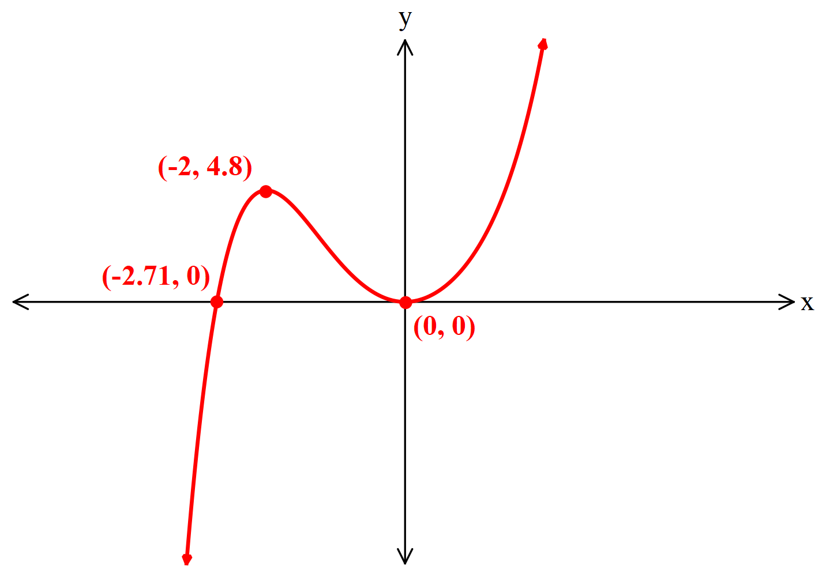

Question 9 | [1, 2, 2 = 5 marks]

A car is travelling in a straight line. The car’s distance $s$ metres, from a fixed point O, is given by,
$s=10+14t+\frac{1}{3}t^{3}$ for $t≥0$, where time $t$ is in seconds.

a) Find the initial velocity of the car.

$v(t)=14+t^{2}$

$v\left(0\right)=14$ ms⁻¹ correct initial velocity

b) Find when the velocity of the car is 18 ms⁻¹.

$18=14+t^{2}$ uses first derivative of displacement to determine the velocity function
and substitutes $v(t)$ for 18
$4=t^{2}$

$t=± 2$

when $t=2$ seconds correct, positive solution only since $t≥0$

c) Find the average speed of the car in the first 4 seconds.

$s\left(4\right)=10+14\left(4\right)+\frac{1}{3}{(4)}^{3}$

$s\left(4\right)=87.\dot{3}$ m determines displacement after 4 seconds

$Average \left|v\right|=\frac{distance travelled}{change in time}$

$=\frac{87.\dot{3}-14}{4}$ ms⁻¹

$=18.\dot{3}$ ms⁻¹ correct average speed

Question 10 | [1, 1, 2, 2 = 6 marks]

A crack in an oil pipe on the ocean floor leaks oil to the surface. The total area of oil contamination on the ocean’s surface, in square kilometres (km²), is modelled by the function, $A=0.05(3t^{3}-55t^{2}+248t)$, where $t$ is the number of days since the pipe started to leak oil.

a) Find an expression for the rate of change in $A$ with respect to $t$.

$\frac{dA}{dt}=0.05(9t^{2}-110t+248)$ or $A=0.15t^{3}-2.75t^{2}+12.4t$

correct derivative $\frac{dA}{dt}=0.45t^{2}-5.5t+12.4$

b) Find the rate of change in $A$ with respect to $t$ after 1 day of the oil starting to leak into the ocean.

${\left.\frac{dA}{dt}\right|}_{t=1}=0.05(9{\left(1\right)}^{2}-110\left(1\right)+248)$

$=7.35$ km²/day correct value

The oil company that owns the pipe are quick to respond to the broken pipe and start to repair the pipe and clean the ocean surface of oil contamination.

c) After how many day is the spread of oil on the ocean surface stopped?

solve $\frac{dA}{dt}=0=0.05(9t^{2}-110t+248)$

$=2.9822$ days solves $\frac{dA}{dt}=0$ and obtains correct value for $t$

$∴$ after 3 days the spread of oil has stopped after 3 days

d) Find the rate of change in $A$ with respect to $t$ after 6 days of the oil starting to leak into the ocean. Briefly
comment on the meaning of this result.

${\left.\frac{dA}{dt}\right|}_{t=6}=0.05(9{\left(6\right)}^{2}-110\left(6\right)+248)$

$=-4.4$ km²/day correct value

The negative rate means the area is getting smaller, that is, the repairs and clean-up are both reducing the area contaminated by oil.
indicates that the negative rate means a reducing area

Question 11 | [1, 3, 4 = 8 marks]

A rectangular sheet of cardboard, 40 cm by 60 cm, is to be made into a closed rectangular box. A square of side,
$x$ cm, is removed from each of the corners A and B of the cardboard. A rectangle $x$ cm by $y$ cm, is removed from each of the corners C and D of the cardboard.
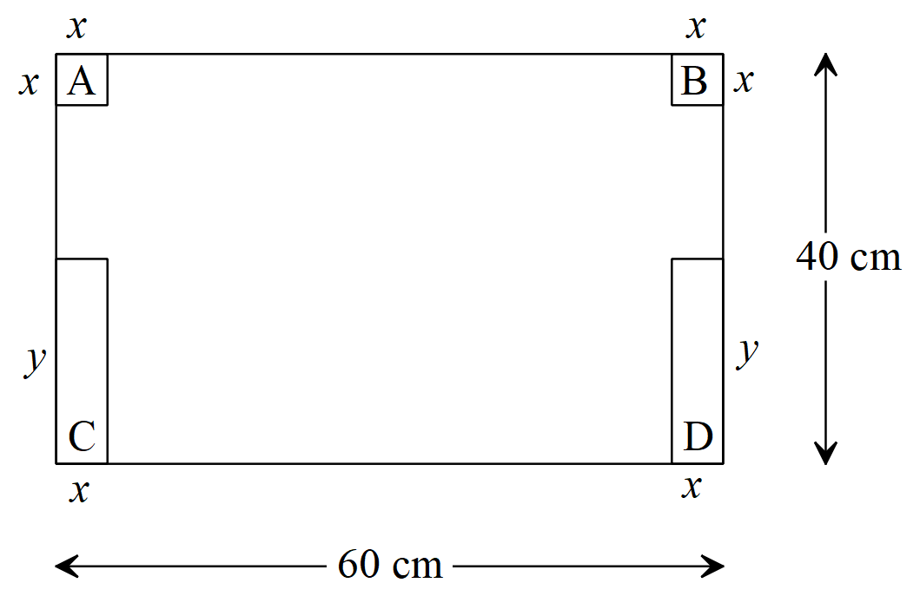
a) Show that the length of the box is given by $L=60-2x$.

$60=L+2x$

$∴L=60-2x$

shows that the 60 cm side of the cardboard sheet
makes the box length plus $2x$

b) Show that the volume, $V$, of the box is given by
$V=x(60-2x)(20-x)$

Let $W=$ the width of the box

$∴40=y+x+W$

However, $y=W+x$

$∴40=2W+2x$
shows that the 40 cm side of the cardboard sheet makes twice the box width plus $2x$
$∴W=20-x$
determines the expression for width in terms of $x$

The height of the box will be given by $x$

i.e. $H=x$ indicates the height of the box is length $x$

since $V=H×L×W$

$∴V=x(60-2x)(20-x)$

c) Use calculus to find the dimensions of the box that will maximise its volume, all correct to 2 decimal places.

$V=2x^{3}-100x^{2}+1200x$

$\frac{dV}{dx}=6x^{2}-200x+1200$ determines $\frac{dV}{dx}$

solve $\frac{dV}{dx}=0=6x^{2}-200x+1200$

$x=7.85$ cm or $x=25.49$ cm solves $\frac{dV}{dx}=0$ for height $x$

discounts the solution $x=25.49$ for the height as the corresponding width will be negative
(either formally as a statement or informally by not including it as a solution)

$∴H=7.85$ cm $L=44.30$ cm $W=12.15$ cm

states all three dimensions correctly

